David L. Suddjian
Biological Consulting Services

801 Monterey Avenue, Capitola, CA 95010
Telephone 831· 479· 9603, email dsuddjian@aol.com

Summary of 2005
Corvid Monitoring Surveys

In The Santa Cruz Mountains

Prepared for

Command Oil Spill Trustee Council

Prepared by

David L. Suddjian
Biological Consulting Services
801 Monterey Ave., Capitola, CA 95010

September 28, 2005
Final Report

INTRODUCTION

In 2002 David Suddjian (unpubl. data) conducted a pilot study in Big Basin Redwoods State Park, Portola Redwoods State Park, Butano State Park, and San Mateo County Memorial Park (Figure 1) to compare relative abundance of corvids in areas of high human use with those well removed from areas of high use. In 2003 the Command Oil Spill Trustee Council (COSTC) initiated a corvid monitoring program in the same four parks that was patterned closely the 2002 effort (Suddjian 2004). The COSTC study was to assist the Council in restoration planning for potential projects benefiting the Marbled Murrelet (Brachyramphus marmoratus), including corvid management. This report presents the results of corvid monitoring surveys conducted in 2005.

Corvids are among the most significant predators on eggs and chicks of marbled murrelets (Nelson 1997, Peery et al. 2004). Both Steller’s Jay (Cyanocitta stelleri) and Common Raven (Corvus corax) have been documented to prey on murrelet eggs or chicks in the Santa Cruz Mountains (Singer et al. 1991, Suddjian 2003, 2003b, Perry et al. 2004), and Peery et al. (2004) demonstrated rates of nest predation as high as 61-87% in the region. The Steller’s Jay has apparently always been a prominent member of the avian community in old growth forests in this region. In contrast, Common Ravens are relatively new in those forests, and have only become numerous in recent decades (Figure 2; Kelly et al. 2002). Both species are attracted to campgrounds and other areas of parks with high human use, where human food is often readily available. Consequently, previous studies and general observations in the Santa Cruz Mountains have typically found both Steller’s Jay and Common Raven to be much more numerous at campgrounds than away from campgrounds. A third species of corvid, American Crow (C. brachyrhynchos), was recorded in the study area for the first time this year (one shot at Huckleberry Campground at Big Basin on April 6, P. Halbert pers. comm.). However, at present this is the only record from the interior part of Big Basin (they are rare non-breeding visitors coastward at the Rancho Del Oso unit), and crows do not yet occur at the other three parks.

This study compares corvid populations in murrelet nesting habitat within campgrounds (treatment areas) to corvid populations in such habitat in areas located >300 meters from campgrounds (control areas). It also provides a baseline from which to judge future changes in numbers related to corvid management projects. Such projects were initiated in 2005.

Methods

Study Design

The pilot study in 2002 sampled corvids in nine treatment areas and 19 control areas (D. Suddjian unpublished data). The monitoring program initiated by COSTC in 2003 established and surveyed one or more treatment and control areas in each park in 2003, except at Memorial, where no suitable control areas were identified (Table 1, and Figures 3-6). All of the treatment and control areas selected for the COSTC study overlapped entirely or partially with areas surveyed by Suddjian in 2002. Surveys in 2003 to 2005 sampled seven treatment areas and 12 control areas. All survey sites are in coast redwood (Sequoia sempervirens) forest known to support use by Marbled Murrelets, with nesting known or suspected to occur either in or immediately adjacent to the survey area. They range in size from 3.2 to 15.7 hectares (Table 1). In 2005 trees with potentially suitable nest platforms (Pacific Seabird Group 2003) were counted in each survey area to provide a measure of the habitat quality of each site for murrelets (Table 2).

Control areas are located a minimum of 300 meters from any campground, picnic area, or residential community, and are located along roads or trails to facilitate access. Treatment areas include standard campgrounds and their immediate surroundings. Group campgrounds were excluded because they were irregularly occupied, and they were often smaller than a minimum size criterion of 3.0 hectares (Suddjian 2004).

Surveys in 2005 were concurrent with initiation of several aspects of corvid management and park-user education in the three state parks (but not at Memorial County Park). These included direct removal of ravens, increased emphasis on proper food storage, increased education about Marbled Murrelets and about corvids as predators, and warnings and citations for campers feeding wildlife or improperly storing food or trash.

Description of Survey Areas

General Patterns Of Human Use

The campgrounds are used continuously throughout the survey period of June to August, although occupancy varies daily and throughout the season. Occupancy is typically at or near 100% on weekends, but often considerably less on weekdays, and is generally greater in July and August than in June. Campground occupancy during the surveys in 2005 ranged from 7% to 71% (Table 3). Average occupancy for each campground in 2005 was reduced from occupancy in 2004, except at Sequoia Flat in Memorial where it was very similar to that of 2004 (Table 3).

Human foods are continually available to corvids in varying degrees at occupied campgrounds. Food is occasionally (but regularly) offered directly to wildlife by campers, but is also widely available as discarded or fallen scraps or fragments, garbage left at camp sites, food fragments stuck on grills at fire rings, and at water spigots where dishes are rinsed. Food left unattended during the day or improperly stored at night is commonly plundered by wildlife. Additionally, in some parks food is readily available at trash receptacles that permit animal access, spillage by animals, are left open, or are too full to close properly.

Human activity in the control areas is mostly limited to hiking, with no established picnic sites. No people other than the surveyor were evident during any of the morning surveys in control areas in 2003 to 2005, with the exception of one park maintenance vehicle that drove through once at one site in 2005.

Big Basin Redwoods State Park

Treatment areas are Blooms Creek Campground (55 sites), Sempervirens Campground (31 sites), Huckleberry Campground (71 sites), and Wastahi Campground (27 sites) (Table 1, Figure 3). Two control areas are located along the upper reach of Opal Creek, and four are along Gazos Creek Escape Road west of Opal Creek (Table 1, Figure 3).

Campgrounds had trash dumpsters with plastic lids, and a small number of metal trashcans with hinged wooden lids. The margins of the plastic and wooden lids on the dumpsters were often chewed by squirrels, enabling them to enter and forage, occasionally dragging trash and food out of the dumpster. Rusted holes in some dumpsters permitted the same access to garbage. The lids on the dumpsters and trashcans were usually closed, but rarely were left open, and occasionally (following weekends) the lid of an overly full dumpster could not be closed, permitting birds and other animals to reach its contents.

Portola Redwoods State Park

The treatment area is the main campground, referred to here as Portola Campground (53 sites; Table 1, Figure 4). The control areas are along Peters Creek north of the campground, and in two areas along the Iverson Trail (Table 1, Figure 4).

The campgrounds and picnic areas at Portola have metal trash bins with animal proof lids. On one occasion in 2005 an overfull trash bin had a large amount of garbage spilled around it., but otherwise there was no spillage was observed around the garbage receptacles in Portola.

Butano State Park

The treatment area is the Ben Ries Campground (61 sites; Table 1, Figure 5). The control areas are along the Butano Service Road extending northeast from the campground, Goat Hill Trial, and Doe Ridge Trail (Table 1, Figure 5).

The campground at Butano had metal trashcans with hinged wooden lids, placed within a wooden receptacle. The lids were heavy enough to prevent animal entry, although the edges of some had been partially chewed. No animal access to the cans or spillage around the cans was observed in 2005.

San Mateo Memorial County Park

The treatment area is the Sequoia Flat Campground (104 sites) (Table 1, Figure 6). No control areas with suitable habitat and sufficient distance from areas of high human use were identified, so control areas for this park were located in Big Basin instead (four areas along Gazos Creek Escape Road, Figure 3).

Sequoia Flat campground had 35 open metal trash cans with no lids, and one small number of metal dumpsters with a plastic lid. Animal access was commonly observed. Trashcans were tipped over and spilled by raccoons and other mammals, and mammals entered the cans and carried garbage out of them onto the ground.

CoRvid Survey Methods

Each site was surveyed using the total area search method (Ralph et al. 1993). The search area at treatment areas included the entire area of campsites and extended outward 50 meters from the edge of the camp boundary. Control areas were established along roads and trails, and the search area extended outward for 50 meters from the center of the road or trail. Thus, the control areas were equivalent to 100-meter wide strip transects in which the total area searches were conducted. Fifty meters was selected as the outside distance to insure the best chance of visual detection of perched, silent birds. Vegetation obscured views too significantly beyond 50 meters. Movement off the road or trail was avoided in control areas to minimize noise made by the surveyor.

David Suddjian conducted all the surveys. Surveys were done by walking slowly through the survey site and pausing often for brief periods, listening for vocalizations and making visual scans to detect corvids. Although Luginbuhl et al. (2001) found that broadcasting taped calls enhanced detections of ravens, this method was not used in this study to avoid disturbance of campers and distraction to the surveyor when campers would inquire about the broadcast calls. Furthermore, the taped calls might attract ravens into the survey areas from outside the boundary during the survey.

Each jay and raven was recorded, indicating its age if known. Aging of ravens was straightforward though the season due to the status of molt of adults, feather wear, vocalizations, and the presence of a pale gape on the juveniles. Aging of jays was easy in June and most of July (using plumage pattern, begging behavior and vocalizations, and the pale gape of the juveniles), but it became more difficult in late July and August, when the juveniles more closely resembled adults and begging activity declined. Behavior of jays and ravens was recorded in notes, particularly as it related to foraging.

Other information recorded for each survey included date, start and end times, weather conditions, number of occupied campsites, number of opportunities to access human food (i.e., spilled trash, unattended food, campers feeding wildlife), and details of foods consumed by corvids.

Survey Frequency and Timing

Four surveys were conducted at each site, with one survey in June, two in July, and one in August. Survey dates in 2005 for each site are given on Table 4. Each site was surveyed only once per day, but often more than one site was surveyed on the same morning. Campgrounds were only surveyed on weekdays. An effort was made to sample each site on dates close to those when it was sampled in prior years.

Each survey occurred in a window beginning 35 minutes after sunrise and extending for up to four hours after sunrise. The rationale for selection of this window of time for the surveys was described in Suddjian (2004). The time required to cover each survey area varied with the size of the area, but the average rate of coverage was 3.1 minute per ha (± 0.6 minute). The time expended in each area was kept fairly consistent over each four replications, and each year.

Analyses

Analyses comparing treatment and control areas used only the maximum number of corvids detected on any of the four surveys of each area (Luginbuhl et al. 2001), although average counts are also presented in the tables. No effort was made to distinguish among ages of corvids for these analyses. Values of p < 0.05 were considered statistically significant, while values 0.1> p > 0.5 were considered marginally significant.

Some comparisons are made to the results of the preliminary study of 2002 (D. Suddjian unpubl. data) for all sites pooled together, as the sites were either the same as those of the COSTC-sponsored surveys, or overlapped with them broadly, and the surveys methods were the same.

Results

Steller’s Jay

Survey results and statistical comparisons for each park in 2005 are given on Tables 5 and 6. Raw counts for 2003 to 2005 are given in Appendix 1. Steller’s Jays were recorded in all survey areas; they were detected on all 28 surveys in treatment areas, and on 58% of 48 surveys in control areas (Table 4). They were ubiquitous in treatment areas, where overall they were 8.8 times more numerous than in control areas, with the difference being highly significant (Table 5). The higher numbers in treatment areas compared to controls was significant for each park (Table 5).

Steller’s Jay abundance in 2005 was similar to that of 2004 when all parks were pooled (Table 9, Figure 7). A slight negative trend for treatment areas from 2003 to 2005 (r² = 0.38) was not significant (p = 0.19). A negative trend for control areas (r² = 0.94) was marginally significant (p = 0.08), but the absolute change in numbers was very small, as jays were uncommon in those areas (Appendix 1). Over the three years, the ratio of jays in treatment and control areas has remained similar (ranging from 9.7 to 8.8), but has exhibited a marginally significant decrease (p = 0.10). Among parks, jay abundance in treatment areas in Big Basin showed a steady (but non-significant) decline from 2003 to 2005, but there was no consistent trend in the other parks (Figure 8, Appendix 1).

As in past years, jay density in 2005 was positively correlated with the number of occupied campsites in a campground (r² = 0.51, p < 0.001). Jays remained consistently most abundant at Memorial, where they are over twice as numerous as at the other parks, but abundance in the treatment areas in the three state parks was generally similar (Figure 9). The maximum raw count for any area in 2005 was 161 jays at Sequoia Flat Campground at Memorial on July 26. The exceptional abundance at Memorial is presumably due to ready access to garbage in a relatively large campground. Jay numbers increased over the season at all campgrounds (r² = 0.12, p = 0.03), but showed no consistent pattern over the season in control areas (Table 5).

The percentage of juvenile jays in the treatment areas was higher in 2005 than in the previous two years. However, because juveniles might disperse to campgrounds from outlying areas, and adult mortality may vary annually, it is uncertain how closely the percentage of juvenile jays on the surveys reflects actual productivity. Nonetheless, the campgrounds host a substantial numbers of young jays; e.g., there were at least 83 juvenile jays at Sequoia Flat in Memorial on August 25, 2005. The seasonal increase in juvenile jays in the campgrounds was statistically significant (r² = 0.86, p <0.0001, but no significant increase was evident in the control areas, where very few juvenile jays were seen. The low number of juveniles recorded on surveys in the control areas could be an artifact of small samples of birds in those areas, or it might reflect dispersal of juveniles away from those areas to places with better foraging opportunities.

Jay behavior and interactions with people were similar to those observed in previous years (Suddjian 2004, 2005a). Jays were observed taking advantage of spilled garbage, stealing unattended food in camps, and being fed directly by campers. Jays were frequently seen inspecting occupied campsites for food, and were very quick to capitalize on an opportunity to steal unattended food, or to search for food in just-vacated sites. Jays typically began each morning with a highly active search of campsites for food scraps left from the previous night, and visited trash receptacles where nocturnal mammals had made food available. Two places where jays consistently sought and found scraps of food were at the grills of campsite fire rings, and at campground water spigots where campers rinse their dishes. Human foods taken by jays during the surveys were similar to those mentioned in Suddjian (2004).

Common Raven

Survey results and statistical comparisons for each park are given on Tables 7 and 8. Raw counts for 2003 to 2005 are given in Appendix 1. Common ravens were recorded in all seven of the treatment areas in 2005, where they were detected on 57% of the 28 surveys (Table 7). In contrast, they were detected at just two (16%) of the 12 control areas, and on only 4% of 48 surveys (Table 7). Raven numbers in treatment areas exceeded those in control areas by 28 times when the data from all sites was pooled together (Table 8), reflecting the very low abundance in control areas in 2005. Taken individually, the difference between the two areas was significant for each park, but only marginally so for Butano (Table 8).

Common Ravens decreased in overall abundance from 2004 to 2005 by 35% in treatment areas and by 83% in control areas (Table 9, Figure 10). This decrease was reflected in each individual park, except at Memorial, where abundance increased, and change at Big Basin was minimal (Figure 11). However, the changes in absolute numbers of individuals were small. Among the parks, Memorial was the only park to have a relatively large number of ravens every year, although the other parks had relatively large numbers in at least one prior year (Figure 12, Appendix 1).

Ravens were generally uncommon, and no large groups were observed in 2005. Most surveys recorded only one or two adults, rarely three adults. Observations over multiple dates could sometimes indicate if a certain individual or pair was in long term residence in a given area, but it was often not possible to determine an individual raven’s status as local resident or “floater”. Most of the change in numbers from 2004 to 2005 was attributable to a lesser number of juvenile ravens in 2005 (see the assessment of corvid management actions in the discussion section below). Unlike the jay, raven numbers did not increase consistently over the season among the sites (Table 7). Most treatment sites had one pair of adults that was regularly or irregularly present, and in some cases their offspring. Productivity in the parks in 2005 was low overall compared to 2004 and 2002, but was similar to that of 2003 (Suddjian 2004, 2005, and unpubl. data).

At Big Basin there were approximately eight pairs of ravens in the general region of the park containing the survey areas, plus additional single birds. However, only two family groups of fledglings were noted, and fledgling occurred later than normal. Two juveniles were near the south end of Opal Creek Picnic Area beginning July 17, and three juveniles were in the area of Huckleberry and Wastahi campgrounds by July 5. The other resident pairs were apparently unsuccessful or did not nest (see discussion). Raven presence and activity at Blooms Creek and Sempervirens campgrounds was much less consistent through the season than in previous years.

At Portola the pair which resided in the general region of the main campground apparently did not nest in 2005 or had a failed nesting attempt. Raven presence in the main campground area was much less consistent than in prior years. A family group of three juveniles seen north of park headquarters on July 29 was judged to have most likely come from a nest located away from the survey areas (Suddjian 2005b)

At Butano a pair nested in the central area of the park, in the general region of the survey areas. A family with two new fledglings was first evident along Little Butano Creek near the Service Road on July 22. The adults were inconsistently present at Ben Ries Campground, and the family group was not seen there.

At Memorial three pairs were resident in and near the park, but only two produced young. A pair nesting near the central part of Sequoia Flat had two fledglings by July 8, and another near the south end of the campground had two fledglings by July 26. Ravens were continually present at Sequoia Flat campground through the season.

Raven behavior and interactions with people were similar to those described previously (Suddjian 2004 and 2005a). However, compared to 2003 and 2004, ravens generally spent less time in the campgrounds in 2005. As in prior years, they remained wary and did not approach people or take handouts, as did jays. The concentration of naïve fledgling jays at campgrounds continued to attract attention from ravens, and at times seemed to be a principal attraction for them at campgrounds.

Discussion And Recommendations

Population Trends

No significant trends in abundance of jays or ravens were evident over the years of this monitoring program. A detailed comparison of the results of this program with other contemporaneous data sources (i.e., the Christmas Bird Count, USGS Breeding Bird Survey, and the Santa Cruz County Forest Bird Monitoring Program) has not been performed, as such a comparison is beyond the present scope specified for this project. This could be changed in future years, or amended for the present year, pending direction from the COSTC and the contracting agency.

Management Actions

The apparent effectiveness of the various management actions implemented in 2005 to affect corvid populations in the parks is discussed in a separate letter to the COSTC.

Garbage Management

Except for rare events, garbage receptacles and collection by park staff at Portola and Butano appeared to be adequate to eliminate any appreciable food resource for corvids. Two problems were noted at Big Basin: (1) many dumpsters had holes in the lids or bottoms that allowed squirrels to pull garbage out; and (2) it was not uncommon for an overfull dumpster to be left full for more than one day, permitting wildlife access to the contents. These issues could be alleviated by replacing or repairing damaged receptacles, and by emptying dumpsters on Sunday or Monday instead of Tuesday. Memorial Park continues to have the most substantial issues with garbage management, as nearly all receptacles in the park were simply open metal cans. These were emptied most mornings, but nocturnal animals could access the cans when they were the most full, and park staff did not empty all the cans when they made the rounds through the campground.

West Nile Virus

West Nile Virus (WNV) was active in bird populations in the Santa Cruz Mountains for the second year in 2005, but its impact on corvids in the study areas was unknown. A low incidence of bird deaths due to WNV from San Mateo and Santa Cruz Counties suggests it may not yet have had a significant effect. The California WNV information website (http://westnile.ca.gov/2005_casecounts.htm) cited just 10 bird deaths from those two counties, out of 2,534 reported for the state as of September 27, 2005.

Timing of Monitoring Surveys

Comments from the COSTC (C. Andrade via email dated August 16, 2005) raised a concern that the monitoring surveys, by not beginning until June, were not assessing corvid numbers during the period murrelet eggs were being depredated. The original plan put forward by COSTC in spring of 2003 was to include surveys in each month from May to August. Due to delays in contracting that year, the surveys did not begin until June, and the June to August schedule has been continued subsequently. Even without surveys in May, the current June to August schedule does overlap partly with the period of the egg or incubation phase of the murrelet’s nesting cycle (Nelson 1997). Additionally, based on extensive prior observations (Suddjian pers. obs.), the results from June are expected to be largely comparable to numbers of corvids that would be recorded in May. The June surveys are mostly before the period in which juveniles have left the nest, and probably completely precede the period of post-breeding dispersal that might swell numbers of corvids in campgrounds. However, the schedule of monitoring surveys could be adjusted in future years at the direction of the COSTC.

Acknowledgements

Supervising rangers Holly Huenemann (Portola), Gary Strachan (Butano), Mary Hazel and Kevin Williams (Big Basin), and other staff at all the parks provided essential logistical support that facilitated the murrelet surveys.

Literature Cited

Kelly, J. P., K. L. Etienne and J. E. Roth. 2002. Abundance and distribution of the common raven and American crow in the San Francisco Bay Area, California. West. Birds 33:202-217.

Luginbuhl, J. M., J. M. Marzluff, J. E. Bradley, M. G. Raphael, and D. E. Varland. 2001. Corvid survey techniques and the relationship between corvid relative abundance and nest predation. Journal of Field Ornithology 72:556-572.

Nelson, S. K. 1997. Marbled Murrelet (Brachyramphus marmoratus). No. 276 in The birds of North America (A. Poole and F. Gill, Eds.) Acad. Of Nat. Sci., Philadelphia, Pennsylvania, and the Amer. Orn. Union, Washington D.C.

Pacific Seabird Group. 2003. Methods for surveying Marbled Murrelets in forests: a revised protocol for land management and research. Marbled Murrelet Technical Committee. Unpubl. report dated 6 January, 2003.

Peery, M. Z, S. R. Beissinger, S. H. Newman, E. B. Burkett, and T. D. Williams. 2004.
Applying the declining population paradigm: diagnosing causes of poor reproduction in
the marbled murrelet. Conservation Biology 18:1088-1098.

Powell, H. 2005. The accidental reaper – ravens are following people into new habitats. California Wild. Summer 2005. California Academy of Sciences.

Ralph, C. J., Geupel, G. R., Pyle, P., Martin T. E. and D. F. DeSante. 1993. Handbook of field methods for monitoring landbirds. Gen. Tech. Rep. PSW-GTR-144. Pac. Southwest Res. Station, Forest Service, U.S.D.A.

Singer, S. W., Naslund, N. L., Singer, S. A., and C. J. Ralph. 1991. Discovery and observation of two tree nests of the Marbled Murrelet. Condor 93: 330-339.

Suddjian, D. L. 2003. Summary of 2002 Marbled Murrelet monitoring surveys
at Big Basin and Portola State Parks. Unpubl. report. Prepared for the California Dept. of Fish and Game.

Suddjian, D. L. 2004. Summary of 2003 corvid monitoring surveys in the Santa Cruz Mountains. Unpubl. report prepared for the Command Oil Spill Trustee Council.

Suddjian D. L. 2005a. Summary of 2004 corvid monitoring surveys in the Santa Cruz Mountains. Unpubl. report prepared for the Command Oil Spill Trustee Council.

Suddjian, D. L. 2005b. Summary of 2005 Marbled Murrelet Monitoring Surveys in the Santa Cruz Mountains. Unpubl. report prepared for the Command Oil Spill Trustee Council.
Table 1. Attributes of the corvid survey areas.

Human Area Slope Approx. Canopy Composition³

Survey Area Type Use Access¹ (ha) Position² Elevation RW DF TO ILO MA Other

Big Basin Redwoods SP
Blooms Creek Treatment Camp 1 15.7 B 900–1,120’ 1 2 1 2 3 3
Sempervirens Treatment Camp 1 7.2 B 960-1,080’ 1 2 1 2 3 --
Huckleberry Treatment Camp 1,2 13.4 B 980-1,160’ 1 2 1 1 2 --
Wastahi Treatment Camp 1,3 7.2 B 1,020-1,250’ 1 2 1 -- -- --
Opal Creek 2 Control Hiking 1 10.2 B 1,050-1,180’ 1 2 1 3 3 3
Opal Creek 3 Control Hiking 3 6.6 B 1,075-1,225’ 1 2 1 3 3 3
Gazos Creek Road 1 Control Hiking 2 9.4 S 1,120-1,280’ 1 2 1 2 2 --
Gazos Creek Road 2 Control Hiking 2 6.7 S 1,240-1,350’ 1 1 1 2 2 --
Gazos Creek Road 3 Control Hiking 2 7.5 S 1,140-1,320’ 1 2 1 2 2 --
Gazos Creek Road 4 Control Hiking 2 7.5 S 960-1,180’ 1 2 1 2 2 --

Portola Redwoods SP
Portola Treatment Camp 1 8.4 B 350-560’ 1 2 1 1 3 3
Peters Creek Control Hiking 1,3 7.7 B 400-600’ 1 2 1 2 3 3
Iverson Trail 1 Control Hiking 3 7.1 B 320-520’ 1 2 1 2 2 3
Iverson Trail 2 Control Hiking 2,3 6.9 B 350-520’ 1 2 1 3 3 3

Continued on next page,

Table 1, continued

Human Area Slope Approx. Canopy Composition³

Survey Area Type Use Access¹ (ha) Position² Elevation RW DF TO ILO MA Other

Butano SP
Ben Ries Treatment Camp 1,3 9.6 B 400-650’ 1 2 1 3 3 --
Butano Service Road Control Hiking 2 8.1 B 500-670’ 1 2 1 3 3 3
Goat Hill Trail Control Hiking 3 3.2 S 620-840’ 1 2 1 2 3 --
Doe Ridge Trail Control Hiking 3 15.7 S 880-1,120’ 1 1 1 2 3 --

Memorial CP
Sequoia Flat Treatment Camp 1 12.6 B 180-280’ 1 2 1 2 -- 2

1. Access: 1 (paved road), 2 (unpaved road), 3 (trail).
2. Slope position: B (bottom of valley), S (mid-slope), R (ridgeline).
3. Approximate canopy cover by each tree species, classed as 1 (50-100%), 2 (11-49%), 3 (1-10%). Tree species: RW (coast redwood), DF (Douglas-fir), TO (tan oak), ILO (interior live oak), MA (madrone), other (includes California bay, red alder, white alder, and big leaf maple)
Table 2. Number of trees with platforms in each survey area¹.

Area # # # # RW # DF # All

Survey Area (ha) RW² DF All / ha / ha / ha

Big Basin
Blooms 15.7 11 38 49 0.7 2.4 3.1
Sempervirens 7.2 7 16 23 1.0 2.2 3.2
Huckleberry 13.4 28 31 59 2.1 2.3 4.4
Wastahi 7.2 9 8 17 1.3 1.1 2.4
Opal 2 10.2 16 11 27 1.6 1.1 2.7
Opal 3 6.6 6 12 18 0.9 1.8 2.7
Gazos 1 9.4 11 13 24 1.2 1.4 2.6
Gazos 2 6.7 10 9 19 1.5 1.3 2.8
Gazos 3 7.5 13 3 16 1.7 0.4 2.1
Gazos 4 7.5 7 4 11 0.9 0.5 1.5

Portola
Portola 8.4 21 33 54 2.5 3.9 6.4
Peters 7.7 4 22 26 0.5 2.9 3.4
Iverson 1 7.1 16 29 45 2.3 4.1 6.4
Iverson 2 6.9 11 18 29 1.6 2.6 4.2

Butano
Ben Ries 9.6 17 44 61 1.8 4.6 6.4
Service 8.1 3 20 23 0.4 2.5 2.8
Goat Hill 3.2 2 8 10 0.6 2.5 3.1
Doe Ridge 15.7 9 25 34 0.6 1.6 2.2

Memorial
Sequoia 12.6 39 45 84 3.1 3.8 6.7

1. “Platforms” were features in the live crown of a conifer that offered potentially suitable nest sites for Marbled Murrelets; “a relatively flat surface at least 10 cm (4 in) in diameter and 10 m (33 ft) high” Pacific Seabird Group (2003, p. 2).

2. “RW” (coast redwood), “DF” (Douglas-fir).
Table 3. Campground occupancy during the 2003 - 2005 corvid surveys.

Survey Area # Sites Run 1 Run 2 Run 3 Run 4 Avg
‘03 ‘04 ‘05 ‘03 ‘04 ‘05 ‘03 ‘04 ‘05 ‘03 ‘04 ‘05 ‘03 ‘04 ‘05

Big Basin
Blooms 55 73% 67% 44% 76% 75% 36% 80% 55% 71% 75% 71% 53% 75% 67% 53%
Sempervirens 31 61% 65% 52% 87% 87% 16% 94% 61% 65% 74% 74% 65% 79% 72% 49%
Huckleberry 71 54% 37% 48% 86% 80% 21% 55% 38% 39% 70% 52% 37% 66% 52% 36%
Wastahi 27 22% 11% 7% 67% 56% 26% 26% 26% 22% 56% 26% 15% 43% 30% 18%

Portola
Portola 53 25% 17% 13% 83% 28% 23% 47% 25% 21% 23% 26% 25% 44% 24% 20%

Butano
Ben Ries 61 23% 26% 36% 30% 43% 28% 62% 54% 44% 36% 46% 43% 38% 42% 38%

Memorial
Sequoia 104 25% 36% 25% 42% 74% 59% 100% 28% 56% 46% 33% 37% 53% 43% 44%

Table 4. Dates of the 2005 corvid surveys.

Survey Dates

Survey Area Run 1 Run2 Run 3 Run 4

Big Basin
Blooms Creek June 20 July 5 July 19 August 22
Sempervirens June 20 July 5 July 19 August 22
Huckleberry June 20 July 5 July 19 August 22
Wastahi June 20 July 5 July 19 August 22
Opal Creek 2 June 21 July 6 July 21 August 24
Opal Creek 3 June 21 July 6 July 21 August 24
Gazos Creek Road 1 June 18 July 4 July 18 August 23
Gazos Creek Road 2 June 18 July 4 July 18 August 23
Gazos Creek Road 3 June 18 July 4 July 18 August 23
Gazos Creek Road 4 June 18 July 4 July 18 August 23

Portola
Portola June 28 July 13 July 29 August 26
Peters Creek June 28 July 13 July 29 August 26
Iverson Trail 1 June 27 July 12 July 28 August 26
Iverson Trail 2 June 27 July 12 July 28 August 26

Butano
Ben Ries June 15 July 1 July 22 August 11
Butano Service Road June 14 July 1 July 22 August 11
Goat Hill Trail June 14 July 1 July 22 August 11
Doe Ridge Trail June 14 July 1 July 22 August 11

Memorial
Sequoia Flat June 16 July 8 July 26 August 25

Table 5. Number of Steller’s Jays per hectare on the 2005 surveys.

Survey Area Run 1 Run 2 Run 3 Run 4 Max Avg

Big Basin
Blooms 1.40 3.06 2.74 3.38 3.38 2.64
Sempervirens 1.53 2.64 1.94 2.64 2.64 2.19
Huckleberry 2.01 1.94 2.91 2.76 2.91 2.41
Wastahi 0.28 0.69 0.56 0.83 0.83 0.59
Opal 2 0.10 0.10 0.00 0.20 0.20 0.10
Opal 3 0.00 0.30 0.00 0.00 0.30 0.08
Gazos 1 0.11 0.32 0.00 0.00 0.32 0.11
Gazos 2 0.45 0.00 0.00 0.00 0.45 0.11
Gazos 3 0.00 0.27 0.00 0.00 0.27 0.07
Gazos 4 0.00 0.13 0.00 0.13 0.13 0.07

Portola
Portola 2.02 1.90 3.57 3.21 3.57 2.68
Peters 0.26 0.00 0.13 0.65 0.65 0.26
Iverson 1 0.00 0.56 0.00 1.13 1.13 0.42
Iverson 2 0.14 0.00 0.00 0.14 0.14 0.07

Butano
Ben Ries 1.15 1.67 4.48 2.08 4.48 2.34
Service 0.25 0.25 0.49 0.00 0.49 0.25
Goat Hill 0.63 1.25 0.31 0.94 1.25 0.78
Doe Ridge 0.45 0.32 0.06 0.13 0.45 0.24

Memorial
Sequoia 2.86 6.03 12.78 11.27 12.78 8.23

Table 6. Comparison of numbers of Steller’s Jays in treatment and control areas in 2005.

Statistical
Survey Area Avg/ha¹ S.E. N Significance

All parks combined
Treatment 4.4 3.87 7 t = 3.5, p^{(1-tailed)} < 0.001
Control 0.5 0.36 12

Big Basin
Treatment 2.4 1.11 4 t = 4.9, p^{(1-tailed)} = 0.0006
Control 0.3 0.08 6

Portola
Treatment 3.6 0.00 1 t = 5.1, p^{(1-tailed)} = 0.018
Control 0.6 0.49 3

Butano
Treatment 4.5 0.00 1 t = 7.2, p^{(1-tailed)} = 0.009
Control 0.7 0.45 3

Memorial
Treatment 12.8 0.00 1 t = 84.5, p^{(1-tailed)} < 0.0001
Control² 0.3 0.13 4 ²see note

- Average of maximum counts from each survey area.
2. Controls for Memorial CP were located in Big Basin Redwoods SP.

Table 7. Number of Common Ravens per hectare on the 2005 surveys.

Survey Area Run 1 Run 2 Run 3 Run 4 Max Avg

Big Basin
Blooms 0.13 0.00 0.00 0.13 0.13 0.06
Sempervirens 0.14 0.00 0.00 0.00 0.14 0.03
Huckleberry 0.15 0.15 0.37 0.07 0.37 0.19
Wastahi 0.14 0.42 0.28 0.00 0.42 0.21
Opal 2 0.00 0.00 0.00 0.00 0.00 0.00
Opal 3 0.00 0.00 0.00 0.00 0.00 0.00
Gazos 1 0.00 0.11 0.00 0.00 0.11 0.03
Gazos 2 0.00 0.00 0.00 0.00 0.00 0.00
Gazos 3 0.00 0.00 0.00 0.00 0.00 0.00
Gazos 4 0.00 0.00 0.00 0.00 0.00 0.00

Portola
Portola 0.12 0.00 0.00 0.00 0.12 0.03
Peters 0.00 0.00 0.00 0.00 0.00 0.00
Iverson 1 0.00 0.00 0.00 0.00 0.00 0.00
Iverson 2 0.00 0.00 0.00 0.00 0.00 0.00

Butano
Ben Ries 0.10 0.00 0.00 0.00 0.10 0.03
Service 0.00 0.00 0.00 0.00 0.00 0.00
Goat Hill 0.00 0.00 0.00 0.00 0.00 0.00
Doe Ridge 0.00 0.06 0.00 0.00 0.06 0.02

Memorial
Sequoia 0.40 0.40 0.71 0.16 0.71 0.42

Table 8. Comparison of numbers of Common Ravens in treatment and control areas in 2005.

Statistical
Survey Area Avg/ha¹ S.E. N Significance

All parks combined
Treatment 0.28 0.23 7 t = 4.3, p^{(1-tailed)} = 0.0002
Control 0.01 0.04 12

Big Basin
Treatment 0.26 0.15 4 t = 4.24, p^{(1-tailed)} = 0.001
Control 0.02 0.04 6

Portola
Treatment 0.12 0.00 1 p^{(1-tailed)} < 0.0001
Control 0.00 0.00 3

Butano
Treatment 0.10 0.03 1 t = 2.0, p^{(1-tailed)} = 0.092
Control 0.02 0.04 3

Memorial
Treatment 0.71 0.00 1 t = 11.1, p^{(1-tailed)} = 0.0008
Control² 0.03 0.05 4 ²see note

- Average of maximum counts from each survey area.
- Controls for Memorial CP were located in Big Basin Redwoods SP.

Table 9. Number of corvids per hectare in treatment and control areas in the four parks from 2002 to 2005.

Species 2002¹ 2003 2004 2005

Steller’s Jay
Treatment areas 5.39 ± 1.53 6.79 ± 3.65 4.46±2.90 4.37±3.87
Control areas 0.61 ± 0.29 0.66 ± 0.32 0.53±0.26 0.48±0.36

Common Raven
Treatment areas 0.55 ± 0.25 0.22 ± 0.17 0.43±0.24 0.28±0.23
Control Areas 0.09 ± 0.07 0.09 ± 0.14 0.06±0.10 0.01±0.04

- 2002 surveys (D. Suddjian unpublished data)
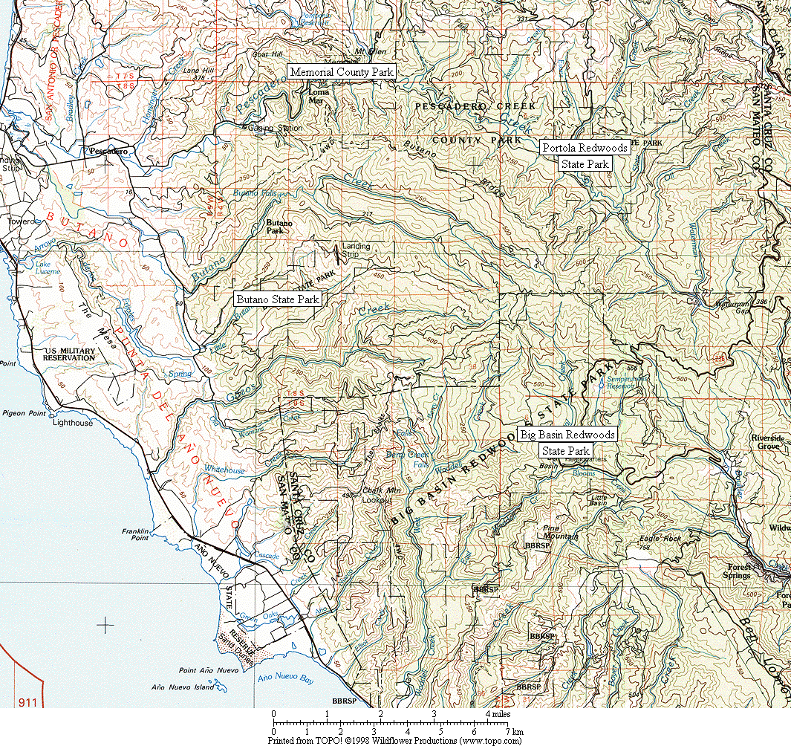

Figure 1. General location of survey areas.

Figure 2. Common Ravens have increased dramatically in all six Christmas Bird Count circles in the Santa Cruz Mountains region. (Note: data presented as a 3-year running mean.)
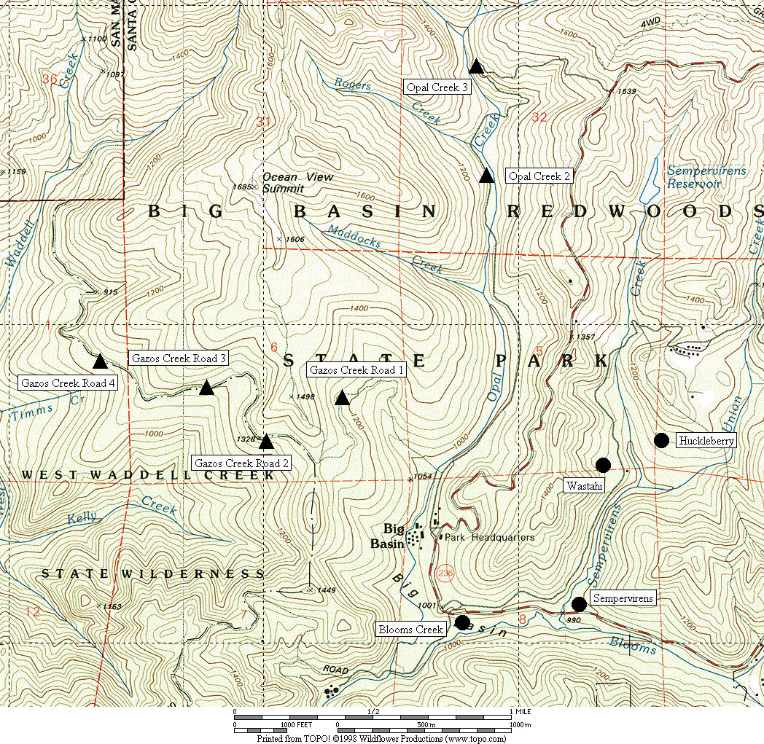

Figure 3. General location of corvid surveys area at Big Basin Redwoods State Park.
● treatment sites ▲ control sites

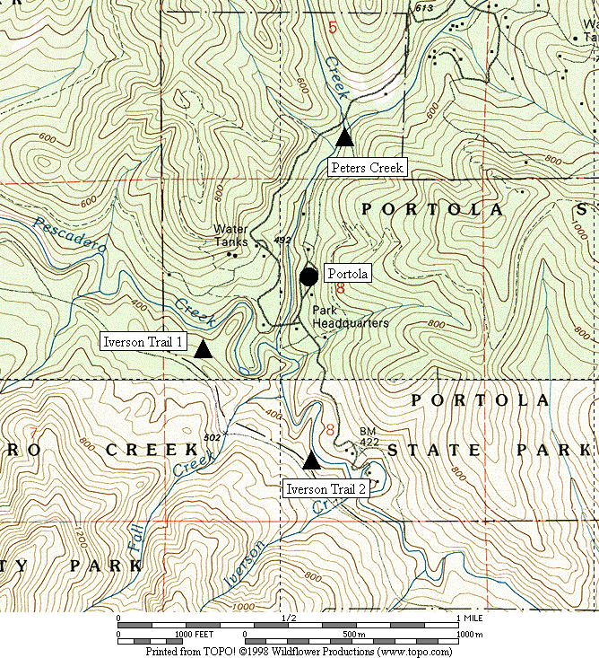

Figure 4. General location of corvid surveys area at Portola Redwoods State Park.
● treatment sites ▲ control sites

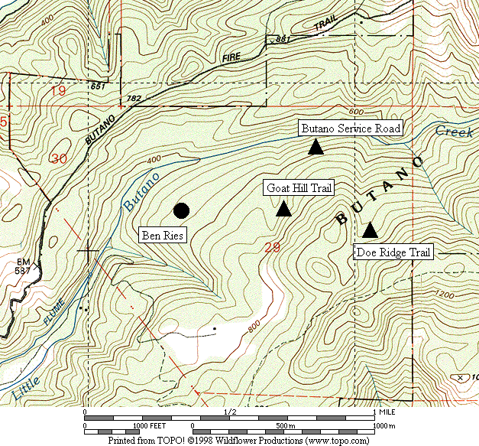

Figure 5. General location of corvid surveys area at Butano State Park.
● treatment sites ▲ control sites

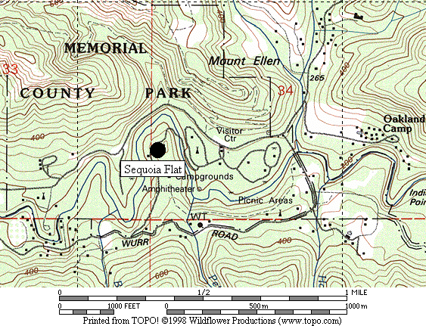

Figure 6. General location of corvid surveys area at San Mateo County Memorial Park.
● treatment sites

Figure 7. Abundance of Steller’s Jay at all sites combined from 2002 to 2005.

A. Big Basin B. Portola

C. Butano D. Memorial

Figure 8. Abundance of Steller’s Jay in each park from 2003 to 2005.

Figure 9. Relative abundance of Steller’s Jays in treatment areas in each park from 2003-2005.

Figure 10. Abundance of Common Raven at all sites combined from 2002 to 2005.

A. Big Basin B. Portola

C. Butano D. Memorial

Figure 11. Abundance of Common Raven in each park from 2003 to 2005.

Figure 12. Relative abundance of Common Raven in treatment areas in each park from 2003-2005.

Appendix 1. Raw numbers of Steller’s Jays and Common Ravens on each survey, 2003-2005.

STELLER’S JAY

Survey Area 2003 2004 2005 Annual Maximum
Run 1 2 3 4 Run 1 2 3 4 Run 1 2 3 4 2003 2004 2005

Big Basin
Blooms 25 47 57 93 27 18 47 36 22 48 43 53 93 47 53
Sempervirens 11 25 33 54 17 19 18 25 11 19 14 19 54 25 19
Huckleberry 41 45 48 102 48 39 23 32 27 26 39 37 102 48 39
Wastahi 10 2 4 23 4 10 15 16 2 5 4 6 23 16 6
Opal 2 3 3 2 1 0 2 1 3 1 1 0 2 3 3 2
Opal 3 4 0 2 0 1 4 2 2 0 2 0 0 4 4 2
Gazos 1 4 4 3 1 2 2 1 1 1 3 0 0 4 2 3
Gazos 2 0 2 2 1 1 1 0 1 3 0 0 0 2 1 3
Gazos 3 1 4 3 0 2 0 2 2 0 2 0 0 4 2 2
Gazos 4 3 2 2 3 1 1 0 0 0 1 0 1 3 1 1

Portola
Portola 7 24 24 37 28 19 20 23 17 16 30 27 37 28 30
Peters 3 4 3 3 1 2 0 3 2 0 1 5 4 3 5
Iverson 1 8 5 6 6 1 3 2 1 0 4 0 8 8 3 8
Iverson 2 3 2 5 2 0 2 3 2 1 0 0 1 5 3 1

Butano
Ben Ries 22 32 35 45 18 34 40 46 11 16 43 20 45 46 43
Service 4 8 3 4 2 2 5 4 2 2 4 0 8 5 4
Goat Hill 4 3 2 3 4 2 2 2 2 4 1 3 4 4 4
Doe Ridge 6 12 5 5 11 7 7 4 7 5 1 2 12 11 7

Memorial
Sequoia 46 71 107 179 46 79 136 133 36 76 161 142 179 136 161

Appendix 1, continued.

COMMON RAVEN

Survey Area 2003 2004 2005 Annual Maximum
Run 1 2 3 4 Run 1 2 3 4 Run 1 2 3 4 2003 2004 2005

Big Basin
Blooms 3 3 0 0 2 2 2 2 2 0 0 2 3 2 2
Sempervirens 1 0 0 0 1 0 4 4 1 0 0 0 1 4 1
Huckleberry 3 3 3 3 2 3 2 4 2 2 5 1 3 4 5
Wastahi 0 0 0 0 1 1 1 1 1 3 2 0 0 1 3
Opal 2 0 0 1 0 1 0 1 1 0 0 0 0 1 1 0
Opal 3 0 3 0 0 0 0 0 0 0 0 0 0 3 0 0
Gazos 1 0 0 0 0 0 0 0 0 0 1 0 0 0 0 1
Gazos 2 0 0 0 0 0 0 0 0 0 0 0 0 0 0 0
Gazos 3 0 1 1 0 0 1 0 0 0 0 0 0 1 1 0
Gazos 4 0 0 0 0 0 0 0 0 0 0 0 0 0 0 0

Portola
Portola 0 4 3 3 1 5 4 2 1 0 0 0 4 5 1
Peters 0 1 0 0 0 0 0 0 0 0 0 0 1 0 0
Iverson 1 0 0 1 0 1 0 0 0 0 0 0 0 1 1 0
Iverson 2 0 0 0 0 0 0 0 0 0 0 0 0 0 0 0

Butano
Ben Ries 1 0 0 1 2 1 6 7 1 0 0 0 1 7 1
Service 1 1 0 1 0 0 0 0 0 0 0 0 0 0 0
Goat Hill 0 0 0 0 0 0 0 0 0 0 0 0 0 0 0
Doe Ridge 0 0 0 0 1 1 0 0 0 1 0 0 0 1 1

Memorial
Sequoia 2 3 4 5 7 5 7 5 5 5 9 2 5 7 9

